
北京启迪赛福通讯技术有限公司

Centel Technology R&D Co., Ltd.

Inazuma Evaluation Report

Inazuma Audio Debug Results

(RE-AU-041229-01)

Doc No：RE-AU-041229-01 |  | Date：2004-11-28 |  | Control No：
Secret Level：High |  | Version：V1.0 |  | Dept：HW
Page： | 15 | Text： | 13 | Appendix： | 0
Editor：Yaming Tan |  | Check：Jinchun Tang |  | Approval：Sean Kang

（Centel Internal Use Only）

AMENDMENT HISTORY

S/N | Rev | Description of Change | Date | Originator | Check | Approval | DCR No.
1 | V1.0 | Original version | 2004-11-28 | Yaming Tan | Jinchun Tang | Sean Kang
2
3
4
5
6
7
8
9
10

- Test Purpose
Adjust audio parameters, in order to check the effect.

- Background
2.1 Background:
Date: 04.11.5
Place: Philips Lab
Engineer: Tan Yaming
Environment: 20℃-25℃,30%-60% RH
HW Version: PR2 and PR3
UUT: Inazuma radios
Speaker PN&supplier: HDR9189-010010(Hosiden)
Receiver PN&supplier: SBR001322M-CW03-C(Sambu)
Mic PN&supplier: ACM4015-02L80-483(AAC)
UUT qty: 6pcs
UUT sampling criteria: Randomly selected
2.2 Equipment:
Base station Simulator R&D CMU200 Module 1100.0008.02
Firm Ware V3.6
Base Equipment
Front Module FMR6
Measurement Equipment
Reference Board 1100.2600.02
RX/TX Board 1135.67.02.02
Digital Board 1100.1804.04
Audio Analyzer R&D UPL160
B&K Conditioning Amplifier
Anechoic Chamber
B&K Artificial Mouth Type 4227
B&K Artificial Ear Type 4192
PC installed Philips TAT Tool
Test SIM Card
Couple Antenna or RF cable (connect radio with CMU200)
2.3 Spec and test theory:
1. Receiving sensitivity/frequency response
The receiving sensitivity frequency response is, as a function of the input test tone frequency, the ratio expressed in dB between the output sound pressure in the artificial ear and the input level.
2. RLR
The nominal Receiving Loudness Rating (RLR) shall be 2 +/- 3 dB.
The maximum Receiving Loudness Rating (RLR) shall not be less than -13 dB
3. Receiving Distortion
The receive signal to total distortion ratio is a measure of the linearity in the receive equipment (excluding the speech decoder).
4. Sending sensitivity/frequency response
The sending sensitivity frequency response is, as a function of the output test tone frequency, the ratio expressed in dB between the output sound pressure in the artificial ear and the input level.
5. SLR
The nominal Sending Loudness Rating (SLR) shall be 8 +/- 3 dB.
6. Sending Distortion
The send signal to total distortion ratio is a measure of the linearity in the receive equipment (excluding the speech decoder).
7.Side Tone Mask Rating
The side tone loudness ratings are a means of expressing the path loss from the artificial mouth to the artificial ear based on objective single tone measurements in a way that relates to how a speaker will perceive his own voice when speaking (talker side tone, expressed by the side tone masking rating -STMR), or how a listener will perceive the background noise picked up by the microphone (listener side tone rating - LSTR).
The nominal value of the Side Tone Masking Rating (STMR) shall be 13 +/- 5 dB.

- Method of Test
3.1 Setup as Figure1.
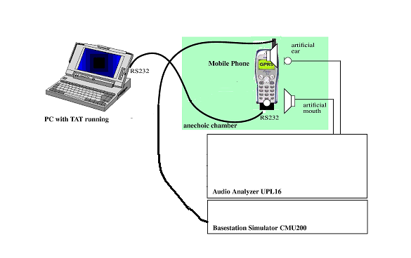
Figure1 Test System Setup
3.2 Calibrate the artificial mouth and artificial ear.
3.3 Insert test SIM card into radio, and install battery into radio.
3.4 Establish call through air interface or RF cable between radio and CMU200.Any channel and TX level is permitted.
3.5 Run 3GPP_TST (auto test s/w in R&D Audio Analyzer UPL16), press button on UPL16 to measure Receive Frequency Response and save results.
3.6 Adjust radio RX volume to Normal (3 bars), then press button on UPL16 to measure RLR (normal) and save results.
3.7 Adjust radio RX volume to Max (5 bars), then press button on UPL16 to measure RLR (max) and save results.
3.8 Press button on UPL16 to Measure Sending Distortion and save results.
3.9 Press button on UPL16 to Measure Receiving Distortion and save results.
4.0 Connect RS232 cable with radio, run Philips TAT tool in PC to adjust audio parameters.
4.1 Repeat step 3.3-3.8 to get microphone performance.

- Test Data and Graph
Table 1: Data Summary for Group1 (3pcs radio with same audio parameters)
MIC Gain | Mic= -48 dB | Mic= -48dB | Mic= -48 dB
Audio parameters | TxPGA= 15  RxPGA= 1A  SidePGA= F  EQ= 1 | TxPGA= 15  RxPGA= 1A  SidePGA= F  EQ= 1 | TxPGA= 15  RxPGA= 1A  SidePGA= F  EQ= 1
MIC supplier | AAC | AAC | AAC
REC supplier | SAMBU | SAMBU | SAMBU
SPK supplier | HOSIDEN | HOSIDEN | HOSIDEN
Radio S/N | 355160000004476 | 355160000000847 | 355160000004963
Volume Setting | 2 | 2 | 2
SLR (5~11dB) | 9.06 | 9.54 | 8.98
RLR Normal(-1~+5dB)  RLR Max (>+-13dB) | Normal: -0.35  Max: -10.12 | Normal: -0.47  Max: -10.24 | Normal: -0.13  Max: -9.61
SFR | OK (PIC1) | OK (PIC4) | OK (PIC7)
RFR | NG (PIC2) | NG (PIC5) | NG (PIC8)
STMR (8~18db) | 16.02 | 15.75 | 15.92
SD | OK (PIC3) | OK (PIC6) | OK (PIC9)
Note
Table 2: Data Summary for Group2 (3pcs radio with same audio parameters)
MIC Gain | Mic= -42 dB | Mic= -42 dB | Mic= -42 dB
Audio parameters | TxPGA= 12  RxPGA= 13  SidePGA= F  EQ= 0 | TxPGA= 12  RxPGA= 13  SidePGA= F  EQ= 0 | TxPGA= 12  RxPGA= 13  SidePGA= F  EQ= 0
MIC supplier | AAC | AAC | AAC
REC supplier | SAMBU | SAMBU | SAMBU
SPK supplier | HOSIDEN | HOSIDEN | HOSIDEN
Radio S/N | 355160000004559 | 355160000003346 | 355160000001233
Volume Setting | 2 | 2 | 2
SLR (5~11dB) | 8.82 | 9.47 | 9.38
RLR Normal(-1~+5dB)  RLR Max (>+-13dB) | Normal: 0.43  Max: -5.63 | Normal: 0.64  Max: -6.65 | Normal: 0.12  Max: -7.16
SFR | OK (PIC10) | OK (PIC13) | OK (PIC16)
RFR | OK (PIC11) | OK (PIC14) | OK (PIC17)
STMR (8~18db) | 15.64 | 15.45 | 13.92
SD | OK (PIC12) | OK (PIC15) | OK (PIC18)
Note
PIC1:
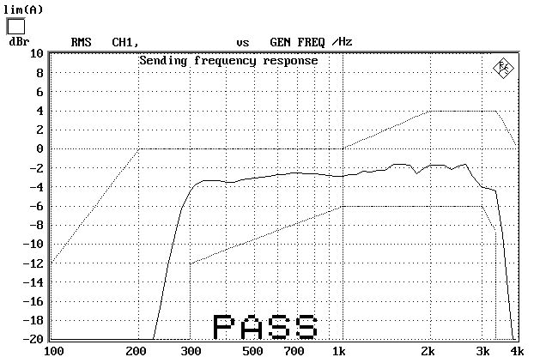
PIC2:
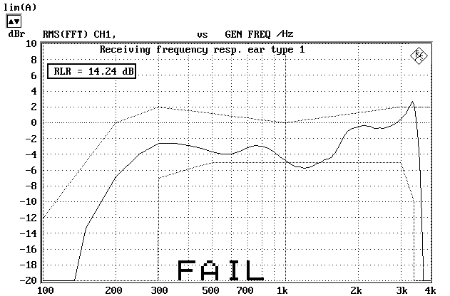

PIC3:
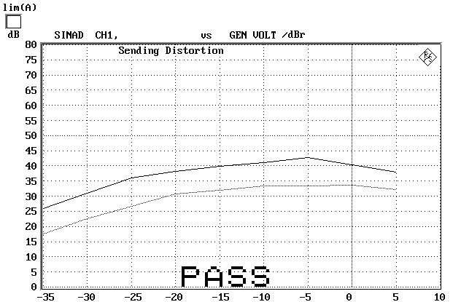

PIC4:
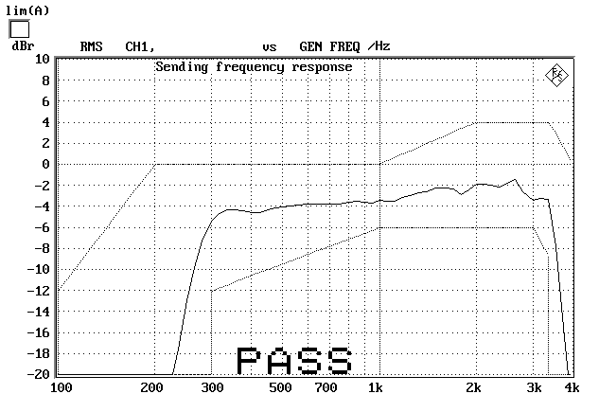

PIC5:

PIC6:
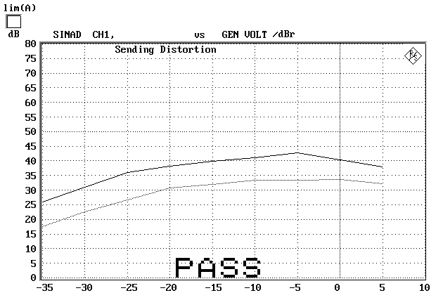

PIC7:
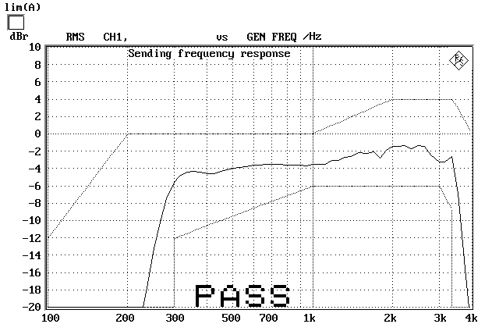

PIC8:

PIC9:
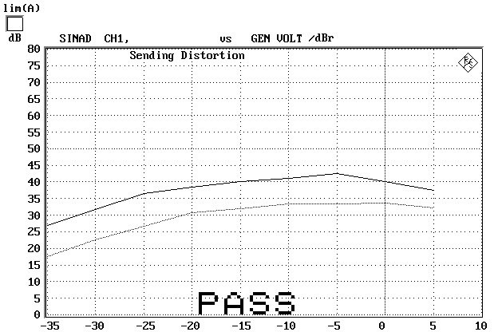

PIC10:
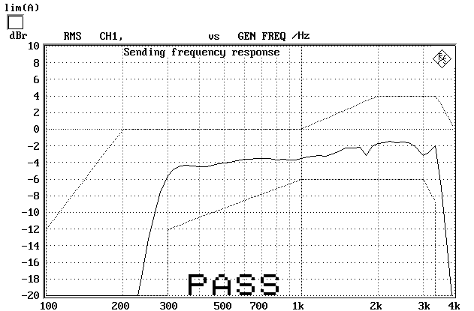

PIC11:
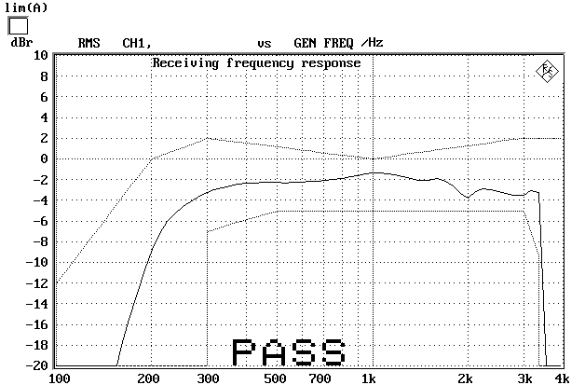

PIC12:
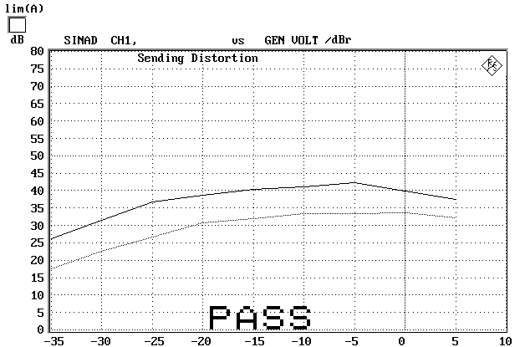

PIC13:
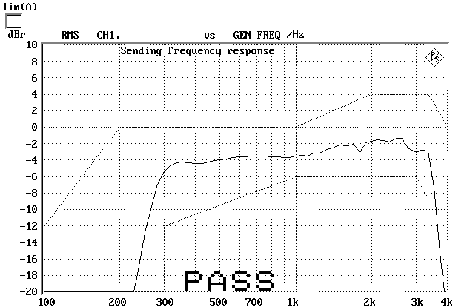

PIC14:
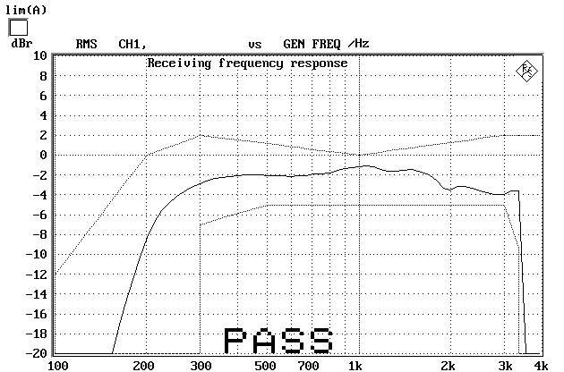

PIC15:
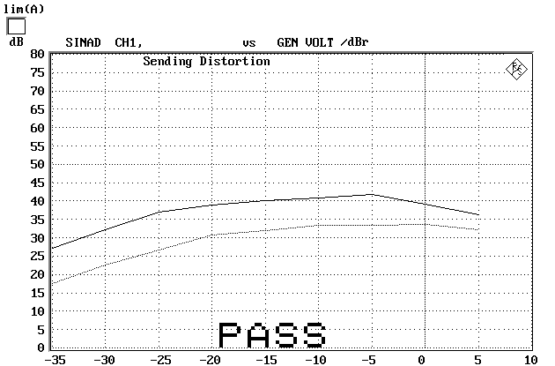

PIC16:
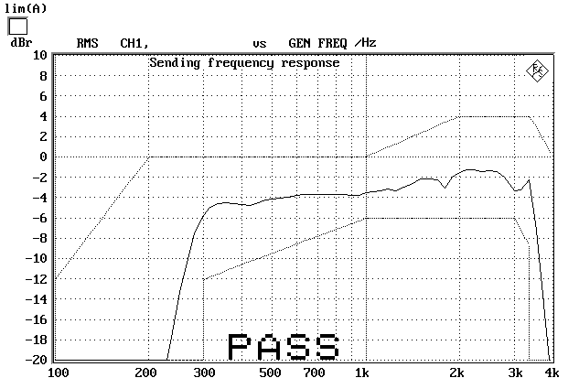

PIC17:
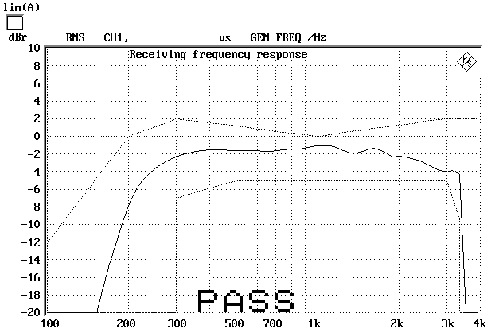

PIC18:
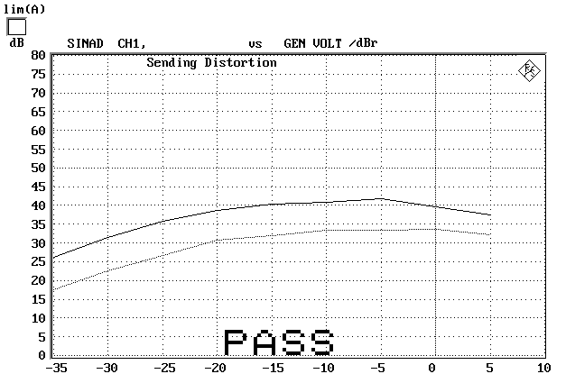

5. Issue list
No | Date | Version | Issue | Reason | Action | Champion

6. Conclusion
- SFR OK
- RFR Group1 not OK, Group 2 OK, but the Field Test feeling of Group 1 is better.
- SD OK
- SLR PASS
- RLR Normal PASS
- RLR Max PASS
- STMR PASS

7. Advice
None

